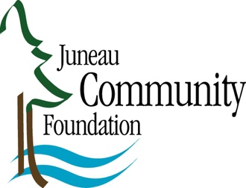

Press Release December 4, 2020

Juneau Community Foundation Announces
2020 Individual Artist Awards

Our vibrant arts scene and rich cultural history are among Juneau’s clear strengths. For generations, residents have supported, created, and maintained a high degree of artistic diversity, ingenuity, and expression. The Foundation’s new hometown grant program for artists, the 2020 Individual Artist Awards, aims to foster local artists. The Foundation announced the four successful applicants: Crystal Cudworth, MK MacNaugton, Christina Apathy, and Ben Huff. Each will receive $2,500 in support of their respective projects.

Crystal Cudworth’s project is a bilingual, multi-media installation consisting of oil paintings, photographs, and sound recordings. Light will flow between media as the viewer experiences stories being told in Lingít and English by Tlingit elders who reside in S.E. Alaska. Their knowledge and personal observations of changes in fishing patterns as seen over a lifetime will be shared, credited, and presented along with large-scale oil paintings and photographs that demonstrate the transformational properties of water.

MK MacNaughton will be developing Adventures at Home a celebration of young people finding innovative ways to entertain themselves during the pandemic. The goal is to connect families, share ideas, and inspire activity through a series of illustrations. Interviews and reference photos of participating kids will be used to create a series of mixed media drawings and paintings incorporating quotes from kids. A digital column will publish monthly throughout 2021, and will be free to the community.

Christina Apathy will use this award to support her acting, directing, and producing of Kate Hamill’s Pride & Prejudice through a workshop and public reading that will help galvanize and introduce a new Juneau based acting company, Theater Alaska, to local audiences.

Ben Huff’s award will support publication of Atomic Island, published by Fw:Books. This photographic project of the Aleutian Island of Adak, will weave together archival images from World War II and the Cold War along with contemporary pictures taken by the photographer over the last five years. The pictures, along with the book, will be exhibited at both the Alaska State Museum and the Anchorage Museum over the next two years.

Developing a long term endowment, the Arts Vibrancy Endowment, that will continue to foster our dynamic arts culture for generations to come is a Foundation priority. Thank you to our generous donors for making the 2020 Individual Artist Awards possible. To learn more, visit www.juneaucf.org.

Contact:

Jamie Waste, Program Director
jamie@juneaucf.org
907-523-5450

