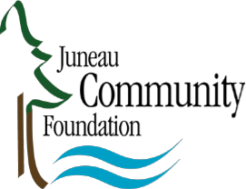

Juneau Community Foundation Douglas-Dornan Fund
Contact: Amy Skilbred Contact: Paul D. Douglas
Tel. (907) 321-8884 Tel. (907) 463-3042
Email: amy@juneaucf.org
FOR IMMEDIATE RELEASE
April 1, 2021
The Douglas-Dornan Foundation Fund Call for Grant Applications
The Juneau Community Foundation’s Douglas-Dornan Foundation Fund is accepting applications for funding support from April 1 through June 1, 2021. This Fund offers grants to organizations that benefit and enhance the health, education and welfare of individuals in Southeast Alaska.
Examples of possible Foundation financial support include, but are not limited to:
-Charitable organizations, foundations or other non-profit 501(c) (3) organizations, or child care institutions, foster parent programs and early childhood education programs in Southeast Alaska.
-Individuals, within organizations, who are pursuing special training/education in any field of professional endeavor, for use in defraying costs for tuition, transportation or lodging expenses related to attendance at professional conferences, training or educational programs.
-Events or special services that enhance the overall quality of life, such as through amateur sports organizations or children’s music and theatre activities, and encourage participation through sponsorship of programs and events open to all individuals.
Applications will be evaluated based on the quality of program to be supported or attended, reasonableness and accuracy of proposed budget, background and experience of applicant, support from other sources, and appropriateness to the objectives of the Fund.
To find out more about this grant opportunity or to get an application form please visit our website at www.juneaucf.org or contact Paul D. Douglas, Advisor, 3014 Foster Ave., Juneau, Alaska 99801, Phone (907) 463-3042.
Completed applications must be mailed to Paul Douglas and postmarked no later than June 1, 2021.
###

