REQUEST FOR FUNDING
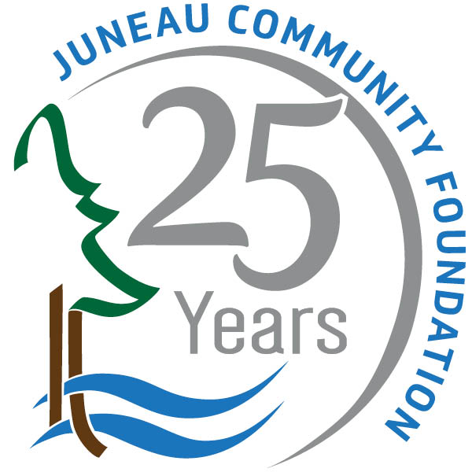
Douglas-Dornan Foundation Fund Juneau Community Foundation

**Note to repeat applicants: there are new submission instructions**
Please read application instructions below

Application instructions:
- Answer grant application questions 1-11.
If you choose to use additional pages please limit to 3 pages.
- Sign the last page of the application and fill out contact information.
- Email your completed application to monica@juneaucf.org
- For questions, please call 907-523-5450 or email monica@juneaucf.org
- Previous grantees can email their reports to monica@juneaucf.org
- Applications due June 1, 2025

Grant Application:
- ORGANIZATION
Name: Tax I.D. No.
Tax Exempt: Yes No
Street/PO Box City/Zip
Preparer’s Name/Title
Telephone: ( ) Email:

- ORGANIZATION DESCRIPTION (Fundamental purpose; mission/goals)

- SPECIFIC PROJECT/PROGRAM TO BE SUPPORTED BY THIS GRANT REQUEST

- SPECIFIC $ AMOUNT REQUESTED
DATE FUNDS ARE NEEDED

- ARE YOU ALSO REQUESTING FUNDING ELSEWHERE? YES NO

IF YES, FROM WHOM, AMOUNT, AND FOR WHAT PURPOSE?

- IF YOU HAVE ALREADY RECEIVED OTHER FUNDING COMMITMENTS, IDENTIFY SOURCE AND AMOUNTS

- FUNDING REQUESTED FOR

Books, materials, supplies Conference support
Equipment
Travel reimbursement Tuition reimbursement Community Activity Education
Honoraria/Stipend Services
Other (describe below)

- JUSTIFICATION
Briefly describe how the funds will promote the health, education and the welfare of persons in Southeast Alaska. Include the specific purpose of the grant request, justification for funding, key persons who will execute use of the funds, and person(s) financially responsible for managing and tracking the use of the funds.

- PROPOSED BUDGET (one-page summary, including limited narrative)

- NO. OF INDIVIDUALS BENEFITING FROM REQUESTED FUNDS

- OTHER COMMENTS

Preparer’s Name (please print)
Signature Title Date
Signature of Organization Head (CEO, Exec. Dir., Manager, Principal, etc.)
Title
Contact Name (please print)
Telephone Email

NOTE: It is expected that all organizations receiving grants will submit a brief status report of the program(s) covered by the grant no later than May 1 of the year following the grant award. This is required to become eligible for future funding.

If you are a repeat applicant, please note that application is now sent to the email listed below.

Email copy to:
monica@juneaucf.org
No later than June 1, 2025

